Database Development Rules

This document outlines the primary objects used in 63BITS database development, including their relationships, naming conventions, guidelines, SQL script formatting, and common techniques for optimal results.

Table of Contents
Database Development Rules 1
Glossary 3
Database Table Rules 4
Table Naming Rule 4
PK-FK Table Naming Rule 4
Column Naming Rule 4
ID Column Naming Rule 4
BIT Column Naming Rule 4
Foreign Key Column Naming Rule 6
Multiple Foreign Keys Columns Naming Rule 7
Naming Multiple Foreign Keys Rule 8
Table Trigger Restrictions Rule 9
Table Must Rules 9
Stored Procedure and Function Rules 11
Stored procedure and Function Naming Rule 11
Parameter and Variable Naming Rule 12
ID Parameter/Variable Naming Rule 12
Variable Type Writing Rule 12
T-SQL Keyword Writing Rule 12
T-SQL Built in Function Writing Rule 12
Alias Naming Rule 13
SELECT Statement Restriction Rule 14
Stored Procedure Development Rules 15
When to use Stored Procedure 15
When not to use Stored Procedure 15
TRY/CATCH Rule 15
Transactions Rule 16
Function Development Rules 17
When to Use Function 17
Multi-Statement Table-Valued Functions Restrictions 17
Formating Rules 18
SELECT Statement Formattin Rule 18
SELECT with JOIN and WHERE Statement Formating Rule 18
GROUP BY Statement Formating Rule 19
INSERT Statement Formatting Rule 19
UPDATE statement Formating Rules 19
DELETE Statement Formatting Rules 20
IF Statement Formating Rule 20
WITH statement (CTEs) Formating Rule 21
MERGE statement Formating Rule 22
IUD Stored Procedure 23
Purpose of the IUD Procedure 23
Naming Rule 25
Parameters Overview 25
TRY/CATCH Block 25
Variable Declarations 25
Capturing Newly Inserted IDs 26
INSERT Logic 26
UPDATE Logic 26
NULL UPDATE Challange 26
DELETE Logic 29
Key Takeaways for Developers 29
List Inline Table-Valued Function 30
Purpose of the List Function 30
Naming Rule 31
Function Execution Script Rule 31
GetSingle Scalar-Valued Function 32
Purpose of the GetSingle Function 32
Naming Rule 33
Return Result Rule 33
Function Execution Script Rule 34

Glossary
Before you begin, take some time to familiarize yourself with the terminology. Simply CLICK on each link, next to the term and read its detailed definition.

⚠️ ⚠️⚠️ These terms will be used all over the documents ⚠️ ⚠️ ⚠️
⚠️ ⚠️⚠️Having a clear understanding of each term, is mission critical⚠️ ⚠️ ⚠️

PascalCase - http://wiki.c2.com/?PascalCase
camelCase - https://en.wikipedia.org/wiki/camel_Case
Primary Key, PK- https://www.sqlservertutorial.net/sql-server-basics/sql-server-primary-key/
Foreign Key, FK - https://www.sqlservertutorial.net/sql-server-basics/sql-server-foreign-key/
Alias - https://www.sqlservertutorial.net/sql-server-basics/sql-server-alias/
Transactions - https://www.sqlservertutorial.net/sql-server-basics/sql-server-transaction/
WITH Statement, Common Table Expression, CTE - https://www.sqlservertutorial.net/sql-server-basics/sql-server-cte/
MERGE Statement - https://www.sqlservertutorial.net/sql-server-basics/sql-server-merge/
Stored Procedures - https://www.sqlservertutorial.net/sql-server-stored-procedures/
Table Valued Functions - https://www.sqlservertutorial.net/sql-server-user-defined-functions/sql-server-table-valued-functions/
Scalar Valued Functions - https://www.sqlservertutorial.net/sql-server-user-defined-functions/sql-server-scalar-functions/
Triggers - https://www.sqlservertutorial.net/sql-server-triggers/sql-server-ddl-trigger/

Database Table Rules
This section establishes the standards for creating and maintaining database tables, including naming conventions, structural design rules, dependency management, and best practices for ensuring clarity, consistency, and long-term maintainability.

Table Naming Rule
Tables in 63BITS databases must be named in PascalCase with the plural form — capitalizing the first letter of each word, no spaces or underscores. The plural form reflects that each table holds a collection of records.
For example, a table storing product data should be named Products, not Product. A table storing product images should be named ProductsImages, not ProductImage or ProductImages.

PK-FK Table Naming Rule
When a table has a FK dependency on PK table, its name must begin with the PK table's name. This makes relationships immediately visible in the database structure.
For example, since a product image cannot exist without its parent product, the image table is dependent on the product table. The correct names are Products for the parent and ProductsImages for the dependent.

Column Naming Rule
Column names must use PascalCase, clearly indicate the column's purpose, and always be singular — beginning with the singular form of the table name. Each column represents one property of one record, which is why the singular form is mandatory.
For example:
- Columns in the Products table: ProductID, ProductName, ProductPrice
- Columns in the ProductsImages table: ProductImageID, ProductImageFilename

ID Column Naming Rule
Column names that represent an identifier must end with ID, where both "I" and "D" are uppercase.

BIT Column Naming Rule
Columns whose data type is bit must contain “Is” keyword after table name prefix.
For example: ProductIsPublished
- Incorrect name: ProductPublished
- Correct name: ProductIsPublished

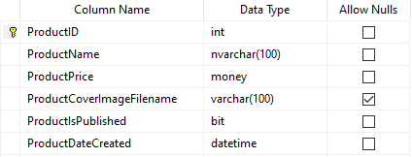

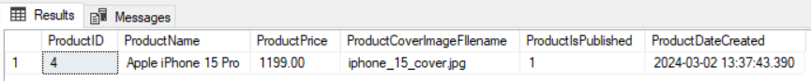

Foreign Key Column Naming Rule
A column representing a foreign key from another table should retain its original name.
For Example: Consider a scenario where products are associated with categories, and all categories are stored in the Categories table. The Products table should include a foreign key column that references the CategoryID, primary key in the Categories table. The foreign key column in the Products table must be named CategoryID, not ProductCategoryID.

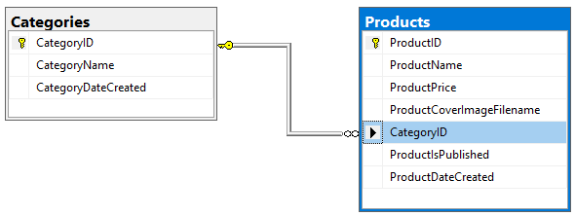

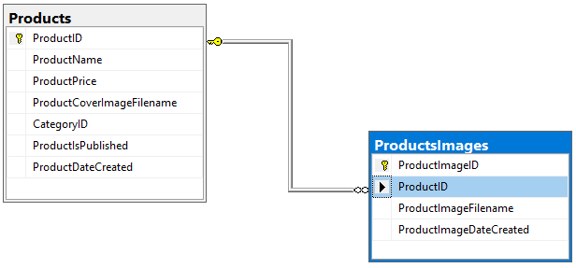

Multiple Foreign Keys Columns Naming Rule
When multiple foreign key columns from the same table reference one primary key column, their names should:
- Begin with the primary key column name.
- End with a clear phrase describing the column's purpose.
Example:
Apple iPhone 15 Pro and Apple iPhone 15 Pro Max are related products. The table for storing information that these two products are related must be named ProductsRelated and contain two foreign key columns linked to the ProductID of the Products table. Since columns cannot share the same name, construct them as follows:
Start column name with ProductID, followed by a short, descriptive suffix.
For Example: ProductIDTarget and ProductIDRelated.
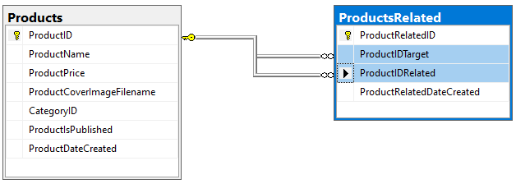

Naming Multiple Foreign Keys Rule
When a table includes several foreign key columns that all reference the same primary key column from another table, the default names given by SQL Server do not accurately reflect how those columns relate to one another.

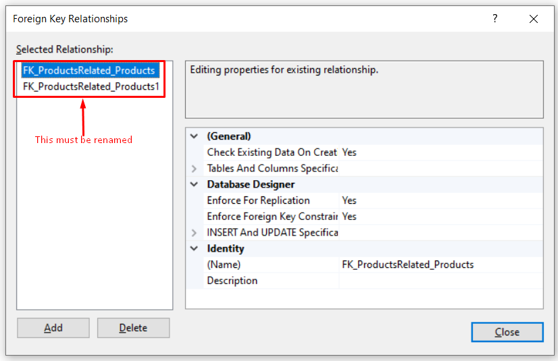

Renaming these keys is mandatory! Use Products and ProductsRelated as example and follow these naming instructions:
- Start with: FK
- Add underscore: _
- Add foreign key table name: ProductsRelated
- Add underscore: _
- Add primary key table name: Products
- Add foreign key column name: ProductIDTarget
The final result is FK_ProductsRelated_Products_ProductIDTarget.

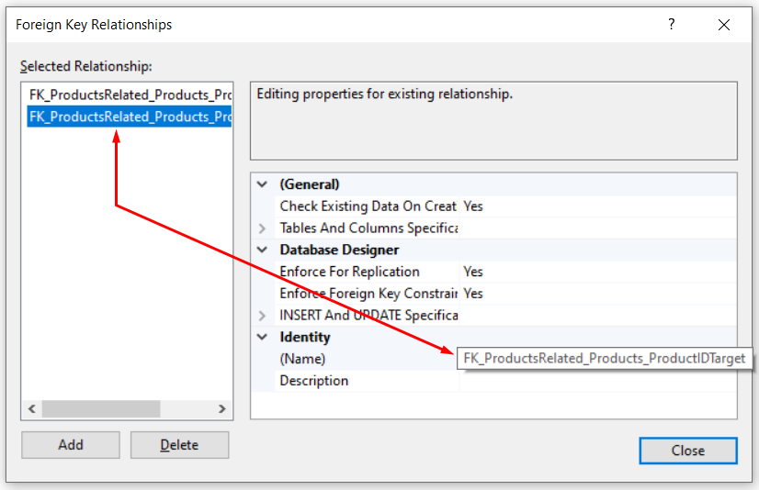

Table Trigger Restrictions Rule
Creating table triggers is strictly prohibited unless explicitly approved by the team lead.

Table Must Rules

Table Must Have a Primary Key
Core tables must have primary keys. Primary key must have Identity Specification property set to Yes and Identity Seed property set to 1.

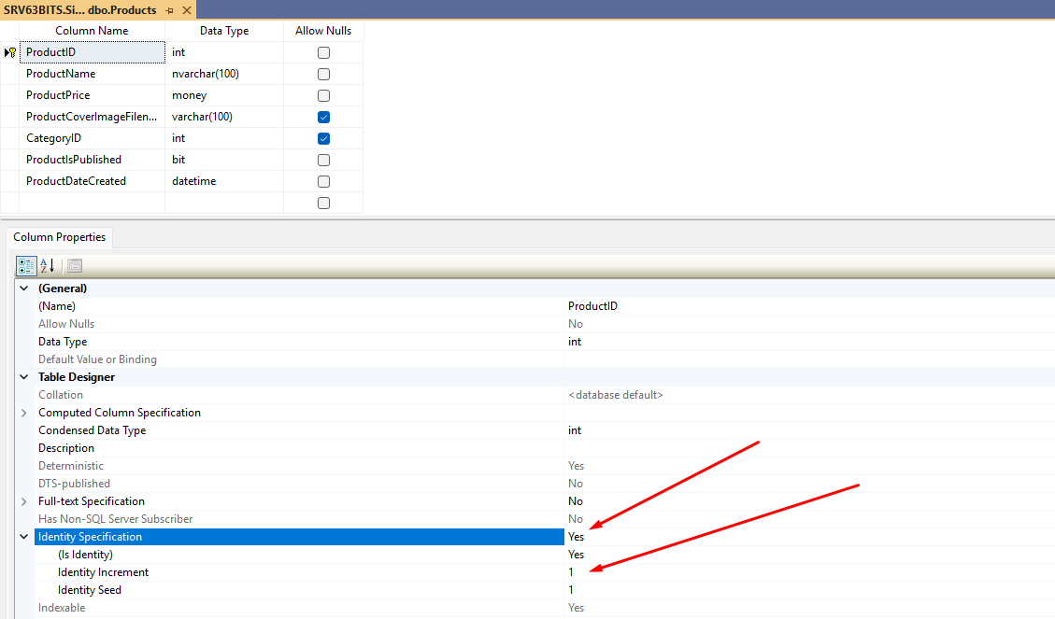

Table Must Have DateCreated column
Table must have a column that should represent a date when record has been created.
For Example: Products table must have ProductDateCreated column.
- DateCreated column type must be datetime
- DateCreated column must NOT ALLOW NULL
- DateCreated column default value must be GETDATE()

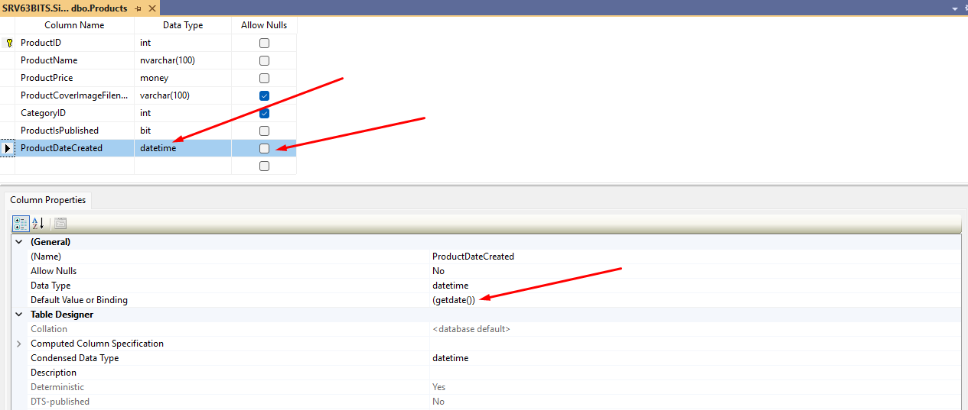

Stored Procedure and Function Rules
This section defines common standards and best naming practices for both stored procedures and functions.

Stored procedure and Function Naming Rule
Stored procedures and Functions must be named in PascalCase — capitalizing the first letter of each word, no spaces or underscores. The name must always begin with the table it operates on, followed by a short, clear description of what it does.
For example,
- Stored Procedure – ProductsDelete
- Table Valued Function – ProductsList
- Scalar Valued Function – ProductsGetSingleByID
Since SSMS lists stored procedures and functions alphabetically, starting every name with the table name naturally groups related routines together — improving readability, navigation, and visual organization.

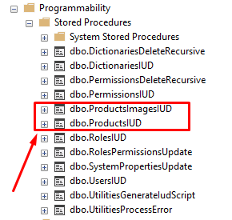

Parameter and Variable Naming Rule
Parameters and variables declared inside stored procedures and functions must use camelCase — lowercase first letter, each subsequent word capitalized, no spaces or underscores.
For example:
- Parameter: @productID int
- Variable: DECLARE @productID int

ID Parameter/Variable Naming Rule
Parameter or Variable that represents an identifier must end with ID, where both "I" and "D" are uppercase.

Variable Type Writing Rule
Variable types always must be named in lower case.
For Example:
int, varchar(50), datetime ...

T-SQL Keyword Writing Rule
T-SQL keywords must always be written in UPPER case.
For Example:
SELECT, INNER JOIN, LEFT JOIN, RIGHT JOIN, INSERT, UPDATE, DELETE, MERGE, USING, DECLARE, WITH, CURSOR, IF, ELSE, BEGIN, END, TRANSACTION ...

T-SQL Built in Function Writing Rule
T-SQL Built in functions must always be written in UPPER case.
For Example:
GETDATE()
REPLACE('original foo bar', 'bar', 'foo')
POWER(2,2)

Alias Naming Rule
Every table in a SQL query must be assigned an alias, formed by capitalizing the initial letter of each word in the table name.
For example:
- Products → P
- ProductsImages → PI

SELECT
P.ProductID,
P.ProductName
FROM Products P

SELECT
PI.ProductImageID,
PI.ProductImageFilename
FROM ProductsImages PI

When the same table appears more than once in a query, append a number to the alias (P1, P2) to distinguish each occurrence.
For Example:

SELECT
PR.ProductIDTarget,
PR.ProductIDRelated,
P1.ProductName ProductNameTarget,
P2.ProductName ProductNameRelated
FROM ProductsRelated PR
INNER JOIN Products P1 ON P1.ProductID = PR.ProductIDTarget
INNER JOIN Products P2 ON P2.ProductID = PR.ProductIDRelated

When the same column is selected from multiple aliases, append a clear, descriptive suffix to each to indicate its source or purpose — as shown above with ProductNameTarget and ProductNameRelated.
SELECT
...
P1.ProductName ProductNameTarget,
P2.ProductName ProductNameRelated
...

For more information about aliases please visit following url: https://www.sqlservertutorial.net/sql-server-basics/sql-server-alias/

SELECT Statement Restriction Rule
The use of SELECT * is strictly prohibited. All queries must explicitly specify column names to ensure clarity, maintainability, and performance. The * asterisk may only be used temporarily for testing or within COUNT(*).

Stored Procedure Development Rules
This section defines the standards and best practices for designing, implementing, and maintaining stored procedures, including naming conventions, parameter usage, transaction handling, error management, and rules governing when stored procedures should or should not be used.

When to use Stored Procedure
Use stored procedures to perform INSERT, UPDATE and DELETE records to database tables, or perform other database specific operations.

When not to use Stored Procedure
Do not use stored procedures to query and return table data directly to the application. Data retrieval should be handled through views, table-valued functions, or scalar-valued functions.

TRY/CATCH Rule
All stored procedures must be wrapped in a TRY/CATCH block to ensure consistent error handling.

CATCH Block Structure
CATCH block must always follow the structure shown below:
BEGIN CATCH
DECLARE
@errorMessage nvarchar(max) = ERROR_MESSAGE(),
@errorProcedure nvarchar(max) = ERROR_PROCEDURE(),
@errorSeverity int = ERROR_SEVERITY(),
@errorState int = ERROR_STATE(),
@errorLine int = ERROR_LINE()

EXEC UtilitiesProcessError @ErrorMessage,@ErrorProcedure,@ErrorSeverity,@ErrorState,@ErrorLine
END CATCH
The - EXEC UtilitiesProcessError – will be explained in more details later in this document.

Transactions Rule
T-SQL TRANSACTION must be used when a stored procedure modifies data in more than one table (Any combination of multple INSERT, UPDATE or DELETE)

Transaction Naming Rule
Transaction names must be an abbreviation of the stored procedure name followed by the suffix Tran. The abbreviation is formed by taking the initial letter of each word in the stored procedure name.
For example, the transaction inside ProductsDelete is named PDTran, where P stands for Products, D for Delete, and Tran is the suffix.

The example below demonstrates how tansaction is inserted into the stored procedure.
CREATE PROCEDURE [dbo].[ProductsDelete]
(
@productID int
)
AS
BEGIN

BEGIN TRANSACTION PDTran
SAVE TRANSACTION PDTran

BEGIN TRY

...

END TRY
BEGIN CATCH
ROLLBACK TRANSACTION PDTran

DECLARE
@errorMessage nvarchar(max) = ERROR_MESSAGE(),
@errorProcedure nvarchar(max) = ERROR_PROCEDURE(),
@errorSeverity int = ERROR_SEVERITY(),
@errorState int = ERROR_STATE(),
@errorLine int = ERROR_LINE()

EXEC UtilitiesProcessError @errorMessage,@errorProcedure,@errorSeverity,@errorState,@errorLine
END CATCH
COMMIT TRANSACTION PDTran
END

Function Development Rules
This section defines the standards and best practices for designing, implementing, and maintaining both table-valud and scalar-valued functions, including naming conventions, parameter usage, transaction handling, error management, and rules governing when stored procedures should or should not be used.

When to Use Function
Functions must be used exclusively for querying and retrieving table data that is returned to the application.

Multi-Statement Table-Valued Functions Restrictions
The use of Multi-Statement Table-Valued Functions is strictly prohibited due to their negative impact on performance and optimization. Exceptions may only be made with prior approval from the team lead.

Formating Rules
This section defines the required formatting standards for SQL queries, including indentation, tab usage, line breaks, and other stylistic conventions.

SELECT Statement Formattin Rule
The following rules must be applied when formating a T-SQL SELECT statement:
- The SELECT keyword starts on a new line.
- Each selected column is placed on its own line, indented one level (TAB) below SELECT.
- The FROM clause follows on the next line, with the table name and its alias on the same line.
Example:
SELECT
P.ProductID,
P.ProductName,
P.ProductPrice,
P.ProductIsPublished,
P.ProductDateCreated
FROM Products P

SELECT with JOIN and WHERE Statement Formating Rule
All standard SELECT formatting rules apply, with the following additions:
- Each JOIN clause is placed on its own line, with the ON condition on the same line.
- The WHERE clause starts on a new line, directly under the JOIN section.
- Each logical operator (AND, OR) is placed on its own line.
- Opening and closing parentheses for grouped conditions are placed on separate lines.
Example:
SELECT
PR.ProductIDTarget,
PR.ProductIDRelated,
P1.ProductName ProductNameTarget,
P2.ProductName ProductNameRelated
FROM ProductsRelated PR
INNER JOIN Products P1 ON P1.ProductID = PR.ProductIDTarget
INNER JOIN Products P2 ON P2.ProductID = PR.ProductIDRelated
WHERE P1.ProductID = @productID
AND
(
P1.ProductIsPublished = 1
OR
@shouldShowUnpublishedProduct = 1
)

GROUP BY Statement Formating Rule
All standard SELECT formatting rules apply, with the following additions:
- The GROUP BY clause is placed on its own line, aligned with SELECT, FROM, and WHERE.
- Each grouping column is placed on its own line, indented one level (TAB) below GROUP BY.
Example:
SELECT
P.CategoryID,
COUNT(P.ProductID) ProductsCount
FROM Products P
GROUP BY
P.CategoryID

INSERT Statement Formatting Rule
The following rules must be applied when formatting a T-SQL INSERT statement:
- INSERT INTO and the table name are on the same line.
- The column list and VALUES block are each wrapped in parentheses placed on separate lines.
- Each column and each value is placed on its own line, indented one level (TAB).

Example:
INSERT INTO Products
(
ProductName,
ProductPrice,
ProductCoverImageFIlename,
CategoryID,
ProductIsPublished
)
VALUES
(
@productName,
@productPrice,
@productCoverImageFIlename,
@categoryID,
@productIsPublished
)

UPDATE statement Formating Rules
The following rules must be applied when formatting a T-SQL UPDATE statement:
- UPDATE TableName SET is written on a single line.
- Each column assignment is placed on its own line, indented one level (TAB).
- A trailing comma follows each assignment except the last.
- The WHERE clause starts on a new line, following the same AND/OR formatting rules as SELECT statements when complex logic is involved.
Example:
UPDATE Products SET
ProductName = @productName,
ProductPrice = @productPrice,
ProductCoverImageFIlename = @productCoverImageFIlename,
CategoryID = @categoryID,
ProductIsPublished = @productIsPublished
WHERE ProductID = @productID

DELETE Statement Formatting Rules
The following rules must be applied when formatting a T-SQL DELETE statement:
- DELETE and the table alias are on the same line..
- The FROM clause follows on the next line, specifying the table name and alias.
- The WHERE clause starts on a new line, following the same AND/OR formatting rules as SELECT statements when complex logic is involved.
Example:
DELETE P
FROM Products P
WHERE P.ProductID = @productID

IF Statement Formating Rule
The following rules must be applied when formatting a T-SQL IF statement:
- The IF condition is written on a single line, evaluating exactly one BIT variable: IF(@bitVariable = 1).
- Multiple logical expressions must never be placed directly inside the IF condition.
- BEGIN and END are always included, each on its own line, even when the block contains only one statement.
- All statements inside the block are indented one level (TAB).
- For complex conditions, declare a BIT variable, pre-calculate the full logical condition, and assign the result to it — keeping the IF condition simple and readable.

Example:
DECLARE @bitVariable bit
SET @bitVariable = ...
IF(@bitVariable = 1)
BEGIN
SET @myVariable = 25
END

WITH statement (CTEs) Formating Rule
The following rules must be applied when formatting a T-SQL WITH statement:
- The WITH keyword is followed by the CTE name on the same line: WITH productsRelatedCte AS
- CTE names must follow camelCase and clearly describe the CTE's purpose.
- Opening and closing parentheses are placed on their own lines, wrapping the SELECT block.
- The SELECT block inside the parentheses is indented one level (TAB).
- All standard SELECT formatting rules apply inside the CTE, including column indentation, JOIN, WHERE, GROUP BY, and logical operator placement.

Example:
WITH productsRelatedCte AS
(
SELECT
P.ProductID,
P.ProductName,
COUNT(PR.ProductRelatedID) ProductsRelatedCount
FROM ProductsRelated PR
INNER JOIN Products P ON P.ProductID = PR.ProductIDTarget
GROUP BY
P.ProductID,
P.ProductName
)
SELECT
P.ProductID,
P.ProductName,
P.ProductsRelatedCount
FROM productsRelatedCte P
WHERE P.ProductsRelatedCount > 3

MERGE statement Formating Rule
The following rules must be applied when formatting a T-SQL MERGE statement:
- MERGE and the target table name are on the same line, with alias T (T = Target).
- USING follows on the next line, aligned with MERGE.
- The source SELECT is wrapped in parentheses, each on its own line, indented one level (TAB), and assigned alias S (S = Source).
- All standard SELECT formatting rules apply inside the source SELECT.
- The ON condition follows on its own line, aligned with MERGE and USING.
- WHEN MATCHED THEN and WHEN NOT MATCHED THEN are each on their own line, at the top indentation level.
- All statements following each WHEN clause are indented one level (TAB).
- UPDATE and INSERT blocks follow their respective formatting rules.
Example:
MERGE Products AS T
USING
(
SELECT
@productName ProductName,
@productPrice ProductPrice,
@categoryID CategoryID
) AS S
ON T.ProductName = S.ProductName
WHEN MATCHED THEN
UPDATE SET
T.ProductPrice = S.ProductPrice,
T.CategoryID = S.CategoryID
WHEN NOT MATCHED THEN
INSERT
(
ProductName,
ProductPrice,
CategoryID
)
VALUES
(
S.ProductName,
S.ProductPrice,
S.CategoryID
);

For more information regarding what is MERGE statement and how it works, please follow the link below: https://www.sqlservertutorial.net/sql-server-basics/sql-server-merge/

IUD Stored Procedure
An IUD stored procedure is a stored procedure designed to perform INSERT, UPDATE or DELETE operations on a single record of a single table.
Instead of creating three separate procedures (one for INSERT, one for UPDATE, one for DELETE), the IUD procedure centralizes all three operations in one reusable, consistent entry point.
For example, a Products table, instead of creating InsertProduct, UpdateProduct, and DeleteProduct, a single procedure ProductsIUD must be created.
IUD stored procedures support flexible updates, allowing to modify any combination of columns in a single row. The UPDATE Logic example, which is provided later below, will demonstrate this capability.

Purpose of the IUD Procedure
This stored procedure:
- Performs exactly one of the actions: INSERT, UPDATE or DELETE.
- Accepts a JSON payload containing column values.
- Uses an OUTPUT parameter to return the inserted ID or pass back the processed ID.
- Wraps the entire operation in a TRY/CATCH block for proper error handling.

CREATE PROCEDURE [dbo].[ProductsIUD]
(
@databaseAction tinyint, -- INSERT(0),UPDATE(1),DELETE(2)
@productID int OUTPUT,
@productJson nvarchar(max)
)
AS
BEGIN

BEGIN TRY

DECLARE
@productName nvarchar(100),
@productPrice money,
@productCoverImageFilename varchar(100),
@categoryID int,
@productIsPublished bit

DECLARE @retVal TABLE
(
ProductID int
);

SELECT
@productName = ProductName,
@productPrice = ProductPrice,
@productCoverImageFilename = ProductCoverImageFilename,
@categoryID = CategoryID,
@productIsPublished = ProductIsPublished
FROM OPENJSON(@productJson)
WITH
(
ProductName nvarchar(100) '$.ProductName',
ProductPrice money '$.ProductPrice',
ProductCoverImageFilename varchar(100) '$.ProductCoverImageFilename',
CategoryID int '$.CategoryID',
ProductIsPublished bit '$.ProductIsPublished'
)

IF @databaseAction = 0 -- INSERT
BEGIN
INSERT INTO Products
(
ProductName,
ProductPrice,
ProductCoverImageFilename,
CategoryID,
ProductIsPublished
)
OUTPUT INSERTED.ProductID INTO @retVal
VALUES
(
@productName,
@productPrice,
@productCoverImageFilename,
@categoryID,
@productIsPublished
)

SELECT TOP(1) @productID = ProductID FROM @retVal
END
ELSE IF @databaseAction = 1 -- UPDATE
BEGIN
UPDATE Products SET
ProductName = ISNULL(@productName,ProductName),
ProductPrice = ISNULL(@productPrice,ProductPrice),
ProductCoverImageFilename = ISNULL(@productCoverImageFilename,ProductCoverImageFilename),
CategoryID = ISNULL(@categoryID,CategoryID),
ProductIsPublished = ISNULL(@productIsPublished,ProductIsPublished)
WHERE ProductID = @productID
END
ELSE IF @databaseAction = 2 -- DELETE
BEGIN
DELETE P
FROM Products AS P
WHERE P.ProductID = @productID
END

END TRY
BEGIN CATCH

DECLARE
@ErrorMessage nvarchar(max) = ERROR_MESSAGE(),
@ErrorProcedure nvarchar(max) = ERROR_PROCEDURE(),
@ErrorSeverity int = ERROR_SEVERITY(),
@ErrorState int = ERROR_STATE(),
@ErrorLine int = ERROR_LINE()
EXEC UtilitiesProcessError @ErrorMessage,@ErrorProcedure,@ErrorSeverity,@ErrorState,@ErrorLine

END CATCH
END

Naming Rule
The IUD procedure name must:
- Start with the primary table name from which data is being retrieved.
- Continue with the suffix “IUD”.

Parameters Overview
@databaseAction tinyint
Indicates which operation the procedure will perform:
- 0 – INSERT
- 1 – UPDATE
- 2 – DELETE

@productID int OUTPUT
- On INSERT, this parameter returns the newly created ProductID.
- On UPDATE or DELETE, it returns the same @productID that was processed.

@productJson nvarchar(MAX)
Contains a JSON representation of the product data.
JSON property names must match the column names in the Products table because they are directly mapped using OPENJSON.
JSON may contain partial sets of values for updating only those columns, which are specifically provided in JSON payload.

TRY/CATCH Block
The entire procedure is wrapped in a TRY/CATCH block.
If an error occurs, it is forwarded to another stored procedure, UtilitiesProcessError (which is always provided for 63BITS databases), along with:
- Message
- Procedure
- Severity
- State
- Line number
The UtilitiesProcessError stored procedure provides consistent and well-structured error reporting, making errors easier to read and understand.

Variable Declarations
A set of local variables is declared to store values extracted from @productJson.
These variable names mirror the table's column names, ensuring consistency.
These variables serve two purposes:
- Mapping JSON → Variables
- Supplying values for INSERT or UPDATE operations

Capturing Newly Inserted IDs
A table variable (@retVal) is used to capture the OUTPUT of the INSERT operation:
OUTPUT INSERTED.ProductID INTO @retVal
Later, the ProductID is assigned to the @productID OUTPUT parameter.

INSERT Logic
When @databaseAction = 0:
- Values are inserted into the Products table.
- The newly generated ProductID is captured via the table variable.
- The OUTPUT parameter is populated.

UPDATE Logic
When @databaseAction = 1:
- The record identified by @productID is updated.
- The ISNULL() function allows partial updates:
  - If a field in JSON is NULL, the existing value is preserved.
  - Only provided values overwrite existing data.

Example:
ProductPrice = ISNULL(@productPrice, ProductPrice)
The ProductPrice value will be updated only if price value is provided via JSON. When price is not provided via JSON ProductPrice column value will remain the same.

NULL UPDATE Challange
Problem
Suppose a user wants to remove the product cover image for an existing product by setting the ProductCoverImageFilename column value to NULL. Following statement will never set NULL to the column, which already has some value in it.
ProductCoverImageFilename = ISNULL(@productCoverImageFilename,ProductCoverImageFilename)
If the caller explicitly sends NULL as a value (intending to clear the field), the ISNULL() function treats it as "no change", preserving the existing value.
As a result:
- There is no way to explicitly set a column to NULL using this pattern.
- NULL is treated as “do not update”, rather than “clear the value”.

Solution
To explicitly request that a column be updated to NULL, we introduce reserved values (also known as sentinel values) for each data type:

Data Type | Reserved Value for NULL
Numeric types | -1
String types | ‘’ (empty string)
Date/Datetime | 1900-01-01

These values signal the IUD stored procedure to update the corresponding column to NULL.
To improve maintainability and avoid hardcoding these constants across procedures, all 63BITS databases already have scalar-valued functions that return the reserved sentinel values:
- dbo.ConstantsNullValueForNumeric()
- dbo.ConstantsNullValueForDate()
- dbo.ConstantsNullValueForString()

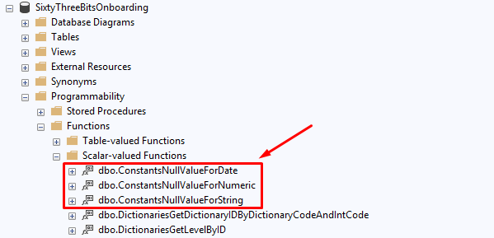

The final solution for the problem is following:
UPDATE Products SET
...
ProductCoverImageFilename = IIF(@productCoverImageFilename = dbo.ConstantsNullValueForString(), NULL, ISNULL(@productCoverImageFilename,ProductCoverImageFilename)),
...
WHERE ProductID = @productID

Use this approach vicely, apply this technique only when it is necessary.

DELETE Logic
When @databaseAction = 2:
- The row with the supplied @productID is deleted.

Key Takeaways for Developers
- One procedure handles all three operations (INSERT, UPDATE and DELETE).
- JSON input keeps the parameters clean and scalable.
- TRY/CATCH ensures consistent error reporting.
- Column-aligned variable names ensure predictable mapping and maintainability.
- ISNULL logic enables partial updates without requiring full object data.
- NULL update challenge solution with predefined reserved values.
- OUTPUT parameter always returns the affected ProductID.

List Inline Table-Valued Function

Purpose of the List Function
A List Inline Table-Valued Function should be created when a query needs to retrieve data from one or more tables and return a set of rows (a collection of records). This type of function encapsulates reusable query logic and can be called from application to improve readability and maintainability.

For Example:
To query all records from Products table ProductsList inline table valued function must be created.
SET ANSI_NULLS ON
GO
SET QUOTED_IDENTIFIER ON
GO
=============================================
/*
SELECT * FROM ProductsList()
*/
=============================================
CREATE FUNCTION ProductsList
(

)
RETURNS TABLE
AS
RETURN
(
SELECT
P.ProductID,
P.ProductName,
P.ProductPrice,
P.ProductCoverImageFilename,
P.CategoryID,
P.ProductIsPublished,
P.ProductDateCreated
FROM Products P
)

To query records from Products table according to wheather product is published or not, ProductsListByIsPublished Inline Table-valued Function, with @productIsPublished parameter, must be created.

SET ANSI_NULLS ON
GO
SET QUOTED_IDENTIFIER ON
GO
=============================================
/*
DECLARE
@productIsPublished bit = 1
SELECT * FROM ProductsListByIsPublished(@productIsPublished)
*/
=============================================
ALTER FUNCTION ProductsListByIsPublished
(
@productIsPublished bit
)
RETURNS TABLE
AS
RETURN
(
SELECT
P.ProductID,
P.ProductName,
P.ProductPrice,
P.ProductCoverImageFIlename,
P.CategoryID,
P.ProductIsPublished,
P.ProductDateCreated
FROM Products AS P
WHERE @productIsPublished IS NULL
OR P.ProductIsPublished = @productIsPublished
)

Naming Rule
The function name must:
- Start with the primary table name from which data is being retrieved.
- Continue with the suffix “List”.
- Optionally finish with a short and clear description of the filtering criteria or logic used to generate the list (only when necessary).
- The filtering description in the function name must not repeat the table name, because it is already included at the beginning
  - Incorrect: ProductsListByProductIsPublished
  - Correct: ProductsListByIsPublished
- Parameter names, filtering columns via equality compare must repeat column names in camelCase:
WHERE P.ProductIsPublished = @productIsPublished

Function Execution Script Rule
All functions must include a comment that demonstrates an example of how the function should be executed. The parameter values used in the example must clearly represent a real and specific use case of the function’s intended behavior.
Example:
=============================================
/*
DECLARE
@productIsPublished bit = 1
SELECT * FROM ProductsListByIsPublished(@productIsPublished)
*/
=============================================
This must be placed right above function declaration: ALTER FUNCTION ProductsListByIsPublished

GetSingle Scalar-Valued Function

Purpose of the GetSingle Function
A GetSingle Scalar-Valued Function should be created when a query needs to return only one row from the table, by its ID or other parameter.
For Example:
To query only one record from Products table by ProductID ProductsGetSingleByID scalar-valued function must be created.

SET ANSI_NULLS ON
GO
SET QUOTED_IDENTIFIER ON
GO
=============================================
/*
DECLARE
@productID int = 4
SELECT dbo.ProductsGetSingleByID(@productID)
*/
=============================================
CREATE FUNCTION ProductsGetSingleByID
(
@productID int
)
RETURNS nvarchar(max)
AS
BEGIN
RETURN
(
SELECT
P.ProductID,
P.ProductName,
P.ProductPrice,
P.ProductCoverImageFIlename,
P.ProductIsPublished,
P.ProductDateCreated,
P.CategoryID,
C.CategoryName,
(
SELECT
PrI.ProductImageID,
PrI.ProductImageFilename
FROM ProductsImages AS PrI
WHERE PrI.ProductID = @productID
FOR JSON PATH
) ProductImages
FROM Products AS P
LEFT JOIN Categories C ON C.CategoryID = P.CategoryID
WHERE P.ProductID = @productID
FOR JSON PATH, WITHOUT_ARRAY_WRAPPER
)
END
GO

Naming Rule
The function name must:
- Start with the primary table name from which data is being retrieved.
- Continue with:
  - GetSingle suffix when the function returns JSON representing a single record from the table.
  - Skip GetSingle when the return value is not JSON and does not represent a single record.
- Optionally finish with a short and clear description of the filtering criteria or logic used in the function.
- The filtering description in the function name must not repeat the table name, because it is already included at the beginning
  - Incorrect: ProductsGetSingleByProductID
  - Correct: ProductsGetSingleByID
  - Incorrect: ProductsIsProductNameUnique
  - Correct: ProductsIsNameUnique
- Parameter names, filtering columns via equality compare must repeat column names in camelCase:
WHERE P.ProductID = @productID
- Scalar Function returing bit value must contain “Is” or “has” keyword after table name prefix.
For Example: ProductsIsNameUnique or ProductsHasPrice

Return Result Rule
The return result, for the GetSingle function, must always be a JSON string, represented as varchar(max) or nvarchar(max) depending on wheather JSON string includes any unicode characters or not.
WHY JSON?
There are three reasons for that:
- JSON provides flexibility of hierachial results.
- Multiple queries or sub-queries can be combined into one and generate unified JSON result.
- JSON can easily be deserialization into C# class.

Example above clearly demonstrates how a single product with a collection of it’s images can be retrieved from the database withing a single query.
The result of the query above will look like:

{
"ProductID": 4,
"ProductName": "Apple iPhone 15 Pro",
"ProductPrice": 1199.0000,
"ProductCoverImageFilename": "iphone_15_cover.jpg",
"ProductIsPublished": true,
"ProductDateCreated": "2024-03-02T13:37:43.390",
"CategoryID": 1,
"CategoryName": "Mobile Phones",
"ProductImages": [
{
"ProductImageID": 1,
"ProductImageFilename": "apple_iPhone_15_Pro_front.jpg"
},
{
"ProductImageID": 2,
"ProductImageFilename": "apple_iPhone_15_Pro_back.jpg"
},
{
"ProductImageID": 3,
"ProductImageFilename": "apple_iPhone_15_Pro_package.jpg"
}
]
}

Which can easlity be deserialized into the following C# record:

public record ProductDTO
{
#region Properties
public int? ProductID { get; init; }
public string ProductName { get; init; }
public decimal? ProductPrice { get; init; }
public string ProductCoverImageFilename { get; init; }
public bool ProductIsPublished { get; init; }
public DateTime? ProductDateCreated { get; init; }
public int? CategoryID { get; init; }
public string CategoryName { get; init; }
public IReadOnlyList<ProductImageDTO> ProductImages { get; init; }
#endregion

#region Nested Classes
public record ProductImageDTO
{
#region Properties
public int? ProductImageID { get; init; }
public string ProductImageFilename { get; init; }
#endregion
}
#endregion
}

Function Execution Script Rule
All functions must include a comment that demonstrates an example of how the function should be executed. The parameter values used in the example must clearly represent a real and specific use case of the function’s intended behavior.
Example:
=============================================
/*
DECLARE
@productID int = 4
SELECT dbo.ProductsGetSingleByID(@productID)
*/
=============================================
This must be placed right above function declaration: ALTER FUNCTION ProductsGetSingleByID

